**+918016712010.                         vivekananda.jana@yahoo.com                    ADDRESS: Hatiberia (Gandhi Nagar B/56),**

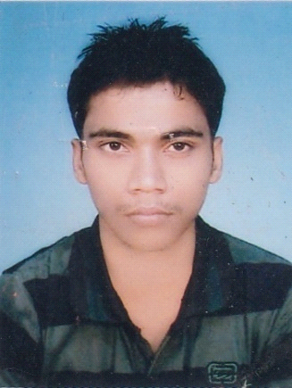

**P.O: Hatiberia, P.S: Haldia, Dist: Purba Medinipur**

**PIN-721657, West Bengal, India**

|  |
| --- |
| **VIVEKANANDA JANA** |

**Objective**

**To associate with an organization where scope for contributing and learning are high. To work as a key player in challenging and creative environment.**

**Academia**

* **Specializing with Marketing of Masters of Business Administration (M.B.A) from Indian Institute of Planning and Management, Kolkata.**

|  |
| --- |
| **Work Experience** |

* **Worked from 01/11/2013 to 31/05/2014 as Business Development Executive in Sri Sri Ramakrishna Enterprise.**
* **Working from 02/11/2015 as Sales Executive at chhaya stationeries pvt ltd.**

|  |  |  |  |
| --- | --- | --- | --- |
| **Projects** |  |  |  |

|  |  |
| --- | --- |
| **TOPIC** | **DURATION** |
| **DISTRIBUTION CHANNEL ANALYSIS OF J.V.L AGRO INDUSTRIES** | **45 DAYS** |

**Academic Qualifications**

|  |  |  |  |  |
| --- | --- | --- | --- | --- |
| **Degree / Certificate** | **College/School** | **University / Board** | **Marks** | **Year** |
| **MBA** | **INDIAN INSTITUTE OF PLANNING AND MANAGEMENT** | **IIPM** | **64.5%** | **2014** |
| **B.sc(HONS)** | **Tamralipta Mahavidyalaya** | **University of Vidyasagar** | **47.5%** | **2012** |
| **Higher Secondary Exams. (12th)** | **R.C.B.M** | **W.B.B.C.H.S.E** | **59.4%** | **2009** |
| **Higher Secondary Exams.(10th)** | **D.S.M.V.** | **W.B.B.H.S.H** | **60.5%** | **2007** |

**Characteristic Strengths**

* Confidence
* Responsible attitude
* Positive Attitude
* Organized discipline and goal oriented

**Personal Particulars**

Date of Birth : 15/04/1992

Nationality : Indian

Hobby : Travelling. study.

Religion : Hindu

Gender : Male

Marital Status : Single

**I hereby, declare that the information provided above is true and complete to the best of my knowledge and belief.**

**DATE:**

**-------------------------------**

**(VIVEKANANDA JANA)**